

**BRAC Bank**

**SME Dashboard**

Web Application User Manual

Document Version 1.0  
09 January 2022

**Disclaimer**

This guide has been validated and reviewed for accuracy. The instructions and descriptions it contents are accurate for BRAC Bank SME Dashboard Web application. However, succeeding versions and guides are subject to change without notice.

**Revision History**

|  |  |  |  |
| --- | --- | --- | --- |
| **Revision No.** | **Created/Updated By** | **Release Date** | **Comments** |
| 1.0 | A S M Lutful Kabir | 09 January 2022 | 1st Release |

Table of Contents

1 About this Guide 5

2 Purpose of this Guide 5

3 Typographical Conventions 5

4 Contact Information 6

5 Application Channel 6

6 Application Login Page 7

6.1 Admin Dashboard 8

6.2 General Dashboard 9

6.2.1.1 Existing SME Lists (Deposit) 10

6.2.1.2 Existing SME Lists (Customer Projection) 10

6.2.2 Upload SME Account 11

6.2.3 Export Upload History (Loan) 12

6.2.3.1 Export Upload History (Deposit) 13

6.2.3.2 Export Upload History (Customer Projection) 13

6.2.3.3 Export Upload History (Employee Info’s) 14

6.2.4 File Upload History 15

6.2.5 Estimated Payment History 16

**6.3** SME Product 17

6.3.1 Add New Products 18

6.3.2 Existing SME Products 19

6.4 User Management 20

6.4.1 Add New User 21

6.4.2 Upload Excel File 22

6.5 Product Campaign 23

6.5.1 Add New Campaign 24

6.6 Role Management 25

6.6.1 Add New Role 26

**No table of figures entries found.**

**List of Figures**

Figure 1 Log in Page 8

Figure 2 Admin Dashboard 9

Figure 3 Existing SME Lists (Loan) 10

Figure 4 Existing SME Lists (Deposit 11

Figure 5 Existing SME Lists (Customer Projection 11

Figure 6 Upload SME Account 12

Figure 7 Export Upload History (Loan) 13

Figure 8 Export Upload History (Deposit) 14

Figure 9 Customer Projection 14

Figure 10 Export Upload History (Employee Info's) 15

Figure 11 Estimated Payment History 16

Figure 12 Estimated Payment History 17

Figure 13 SME Product 18

Figure 14 Add New Product form 19

Figure 15 Add New Products 19

Figure 16 Existing SME Products 20

Figure 17 Existing SME Products (Deposit) 20

Figure 18 User Management System User List 21

Figure 19 Add New User Form 22

Figure 20 Database Relational Table 23

# About this Guide

This document will deliberately guide you to use every possible option/feature of BRAC Bank SME Dashboard, Web application in details.

# Purpose of this Guide

This document describes functional and application level features of BRAC Bank SME Dashboard Web application. However, through this guide user will get conversant with application’s usage/working procedures.

The users/stakeholders of this application should get a rigid overview on the application through this guide.

*User*: The primary users for this module would be Admins of the system and other allotted members/users who would be categorized in the system as:

# Typographical Conventions

|  |  |
| --- | --- |
| **Type Face** | **Meaning** |
| **Bold** | Used to indicate buttons on the screen. |
| *Italic* | Used as special instructions/actions/notes and reference to other sections. |

# Application Channel

The application will be used by intended users on their PC / Laptops via web.

# Application Login Page

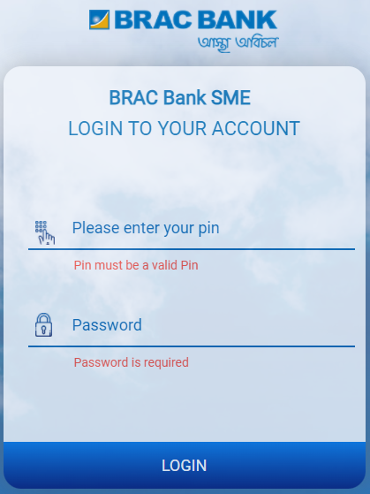The Login page will provide a glimpse of the entire solution. Users from admin roles will be able to login using their unique pin and password.

Figure 1 Log in Page

1

3

2

1. Enter relevant PIN
2. Enter relevant Password.
3. Click on Login button to log in to the system.

## Dashboard

7

6

1

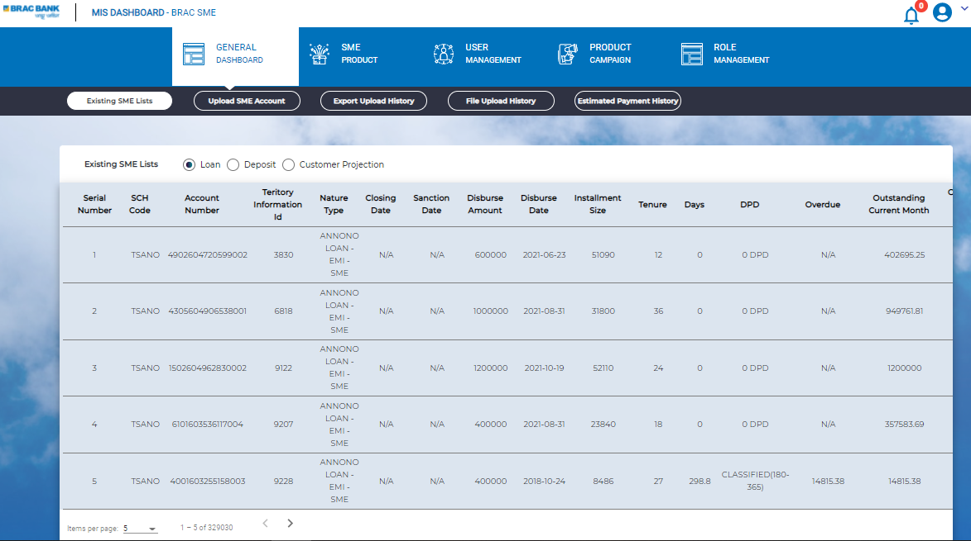

Figure 2 Admin Dashboard

3

2

**5**

1

**4**

1

1

1

1

1

* This is the admin Dashboard
* Here user will find following menus:

1. General Dashboard (Click to access).
2. SME Production. (Click to access)
3. User Management (Click to access).
4. Product Campaign (Click to access).
5. Role Management (Click to access).
6. Notification;
7. Logout;

.

## General Dashboard

Figure 3 Existing SME Lists (Loan)

* In General Dashboard menu user will find following sub menus: Upload SME Account, Export Upload History, File Upload History, Estimated Payment History;
* Here user will find following buttons: Loan, Deposit, Customer Projection in the Existing SME Loan Section;
* Selecting each button will redirect the admin user to relevant page;

#### Existing SME Lists (Deposit)

Figure 4 Existing SME Lists (Deposit

* Clicking on the Deposit button admin user will redirect to Existing SME List for Deposit

#### Existing SME Lists (Customer Projection)

Figure 5 Existing SME Lists (Customer Projection

* Clicking on the **Customer Projection** button, admin user will redirect to Existing SME List for Deposit

### Upload SME Account

Figure 6 Upload SME Account

* Clicking on Upload SME Account sub menu user will redirect to Upload SME Account page;
* Here user will find **Upload Type** dropdown button **(Loan, Deposit, Customer**)
* Clicking on the **Choose File** button user will be able to select the desired file.
* Select relevant **Upload date**;
* Clicking on the **Upload** button user will be able to upload the file.

[**Note: The uploaded files must be in .txt format**]

### Export Upload History (Loan)

Figure 7 Export Upload History (Loan)

* Clicking on the Export Upload History sub menu button user will redirect to Export Upload History Page;
* Here admin user will find following buttons: Loan, Deposit, Customer Projection Employee Info’s;
* Clicking on the buttons, admin user will redirect to relevant page.

#### Export Upload History (Deposit)

Figure 8 Export Upload History (Deposit)

* Clicking on the Deposit button, admin user will redirect Export Upload History Page;

#### Export Upload History (Customer Projection)

Figure 9 Customer Projection

* From here admin user will be to **Export Upload History** of **Customer Projection**

#### Export Upload History (Employee Info’s)

Figure 10 Export Upload History (Employee Info's)

* Clicking on the **Employee Info’s** button user will redirect to the page of Employee Info’s page under **the Export Upload History** sub menu;

### File Upload History

Figure 11 Estimated Payment History

* Clicking on the **File Upload History** sub menu under **General Dashboard** menu admin redirect to **File upload history page**
* Here admin will find upload history of the file
* On the left side of the page admin user will find Date & Time panel.
* Form this panel admin user can get the file upload history of loan by clicking on **Loan** button
* Form this panel admin user can get the file upload history of deposit by clicking on **Deposit** button
* From this panel admin user can get date wise file upload history by clicking on the **Date and Time** button

### Estimated Payment History

Figure 12 Estimated Payment History

* 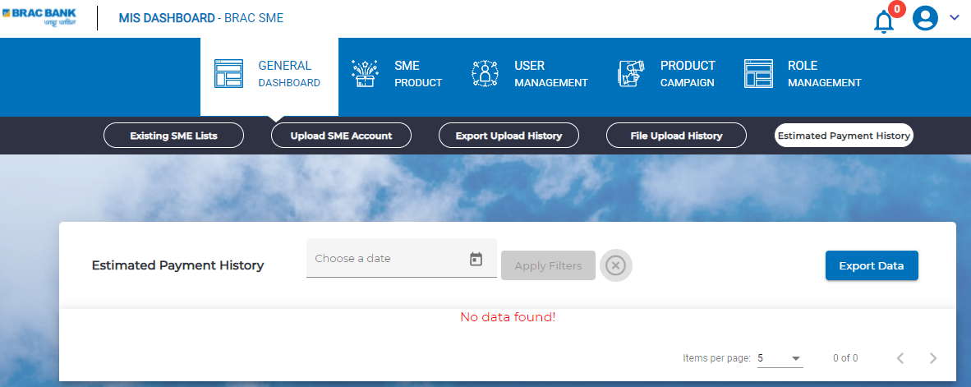Clicking on **Estimated Payment History** sub-menu button under General Dashboard menu, admin user will redirect to Estimated Payment History page
* From the **Choose a date field** user can select relevant date and clicking upon the **Apply Filters** admin user can apply filter.
* Clicking on the **Export Data** button user can export and download relevant file

## SME Product

Figure 13 SME Product

* Clicking on **SME PRODUCT** menu Admin will find following sub menu:

1. Existing SME Products;
2. Add New Products;

### Add New Products

Figure 14 Add New Product form

Figure 15 Add New Products

* Clicking on Add New Products Sub menu button admin will find Create New Product form;
* Here user will find few fields, Check box, button, dropdown button;
* Clicking on the Browse file user will be able to upload desired file from the local device, the image file Name will be shown in Upload Photo field;
* User will be able to select relevant Category Type **(Loan / Deposit)** form the dropdown;
* User will enter the relevant title in the **Product Title** field;
* User will enter the relevant product feature in the **Product Feature** field;
* User will enter the relevant additional information in the **Additional Information** field;
* Clicking on the **Visibility** checkbox will enable visibility.
* Clicking on the **Create** button will Add New Products;

### Existing SME Products

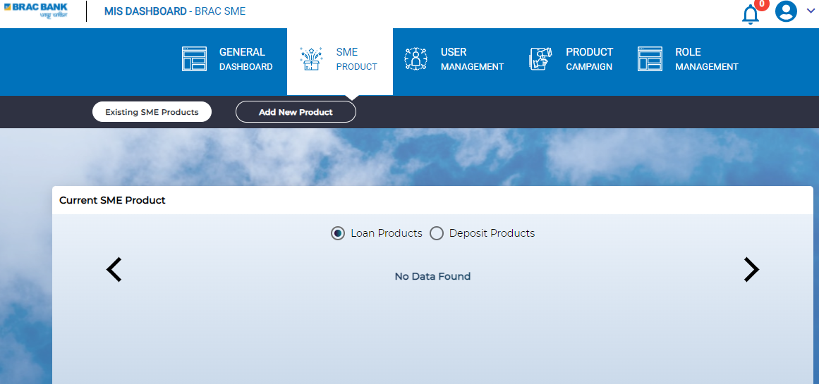

Figure 16 Existing SME Products

* Clicking on Existing **SME Products** sub menu button admin user will redirect to **Current SME Product** page;
* Here admin user will find **Existing SME Products**;
* 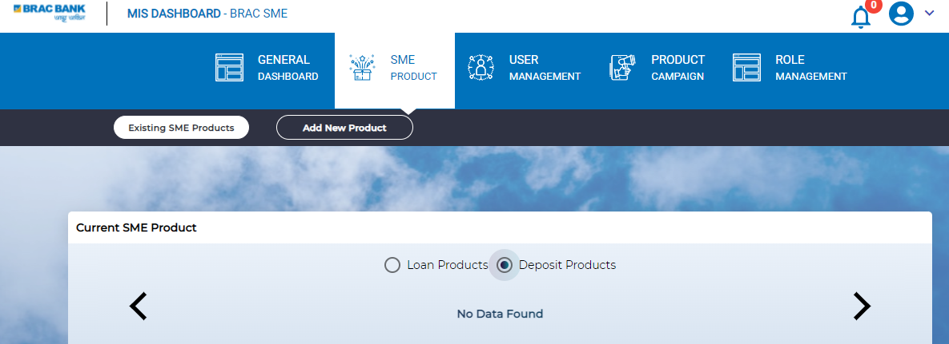Clicking on the **Loan Products** user will find relevant products;

Figure 17 Existing SME Products (Deposit)

* Clicking on the **Deposit Products** user will find relevant products;

## User Management

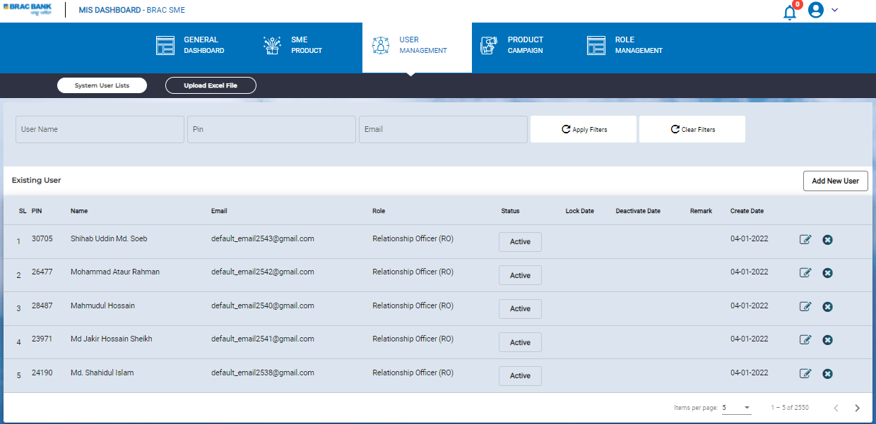

Figure 18 User Management System User List

* Clicking on **User Management** menu user will find following sub menus:
  + 1. System User lists;
    2. Upload Excel file;
* Here user will find List of the users who user the system;
* Here user will find Add New User Button
* Here user will find User Name, Pin, Email based filtering option;
* Clicking on the **Apply Filters** button user will be able to apply filter, Clicking on **Clear Filters** button will reset the filter;
* Clicking on **Active** button from the **Status** column user can **Active / Lock / Inactive** any user;
* Clicking on edit button form the right-side admin user can update / modify information of any user;

### Add New User

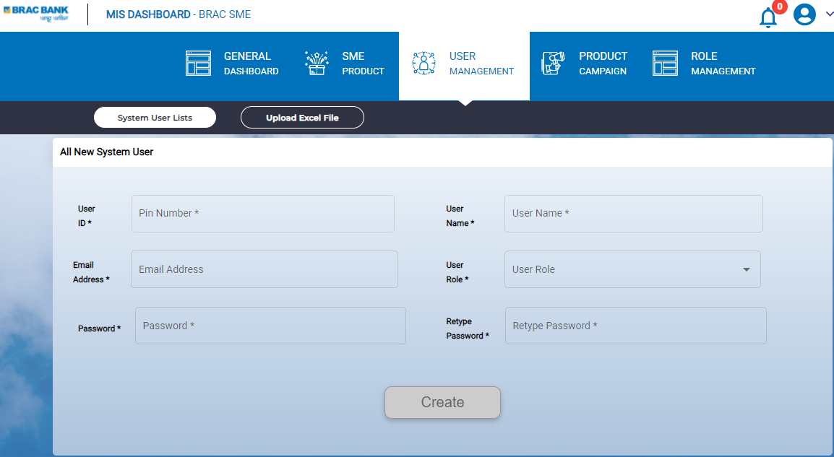

Figure 19 Add New User Form

1. Enter relevant **User ID**;
2. Enter **User Name**;
3. Enter relevant **Email Address** here;
4. Select **User Role** from the dropdown button
5. Enter relevant **Password**;
6. **Retype Password** here;
7. Clicking on **Create** button will create new user

### Upload Excel File

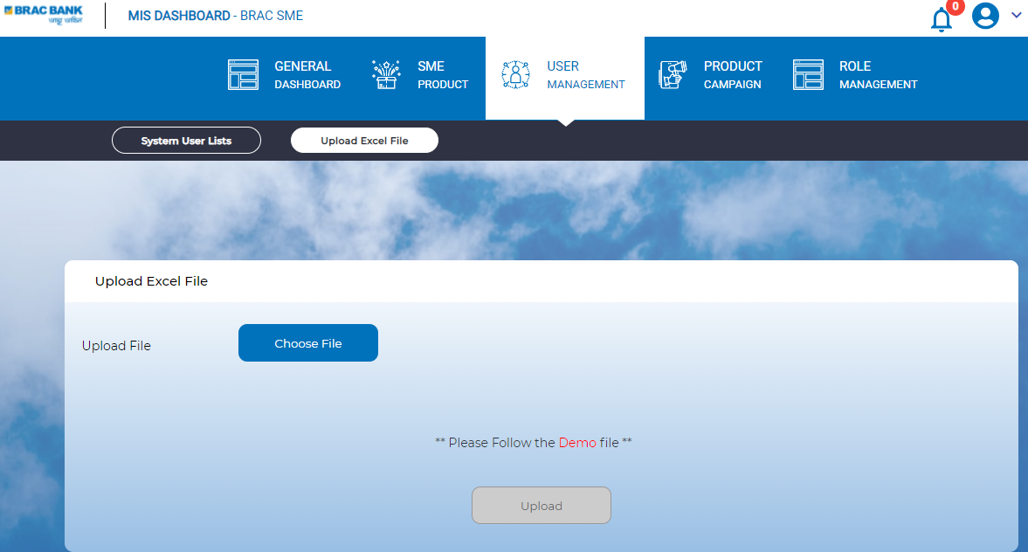

Figure 20 Upload Excel File

* Clicking on Upload Excel File Sub- menu, user will redirect to Upload Excel File Page;
* Clicking on the **Choose file** button admin user will be select relevant file from the local device;
* Clicking on the **Upload** user will be able to upload the file into the system;

## Product Campaign

Figure 21 Product campaign

* Clicking on **Product Campaign** menu user will redirect to **Lists of Campaigns** Page;
* Here user will find **Campaign Lists** and **Add New Campaign** Sub menu;

### Add New Campaign

Figure 22 Add New Campaign form

* Clicking on Add New Campaign sub menu button user will redirect to relevant page;
* Here user will find few fields;
* User will enter Campaign Details on the relevant field;
* User can upload from local device clicking on Browse File button;
* User have to select relevant date in the **From Date** and To **Date field;**
* Clicking on Create button will enable user to create a new campaign;

## Role Management

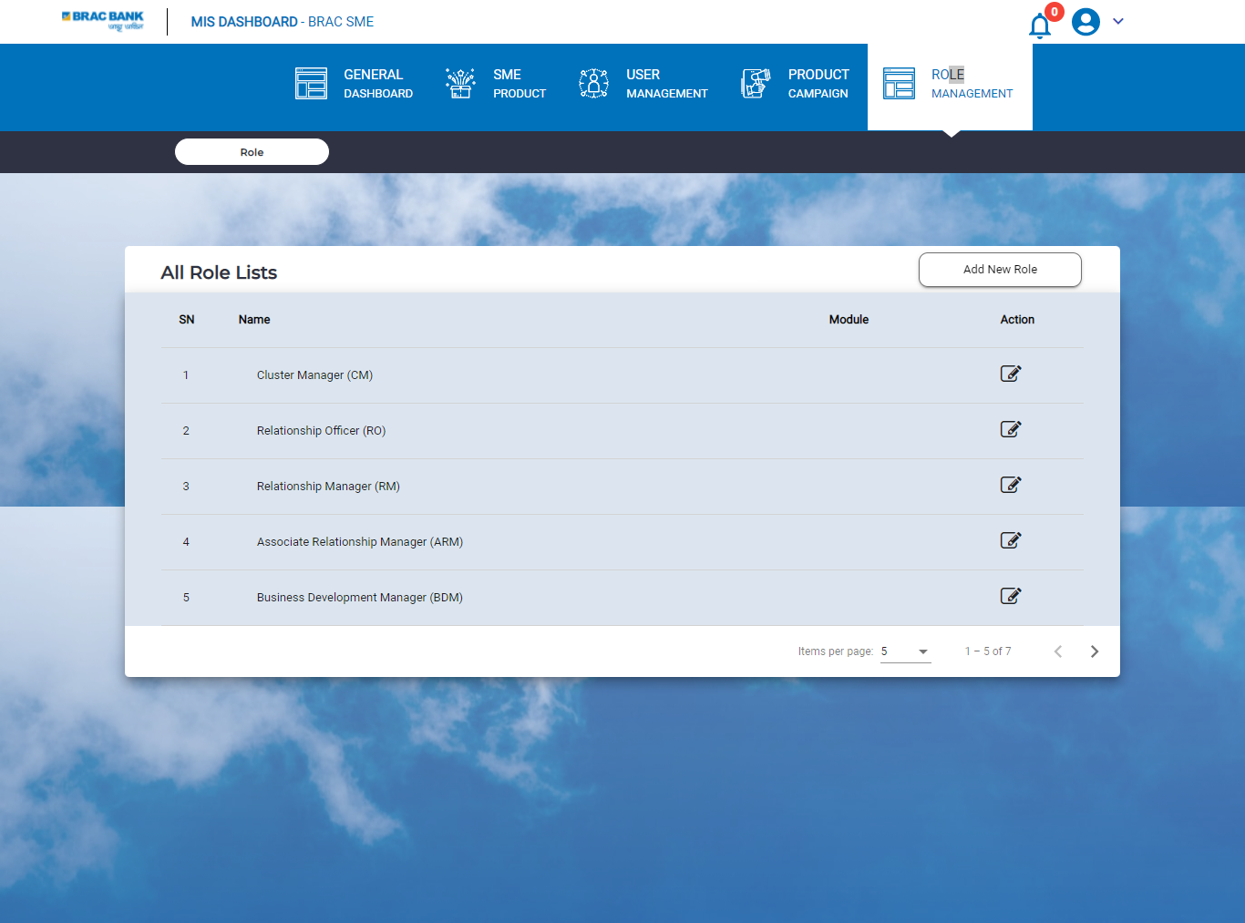

Figure 23 All Role Lists

* Clicking on **Role Management** menu user will redirect to **All Role Lists** page;
* Here user will find all the Name of the User Role for the system;
* Clicking on the on the edit button from the action column user can update or modify any designated column;

### Add New Role

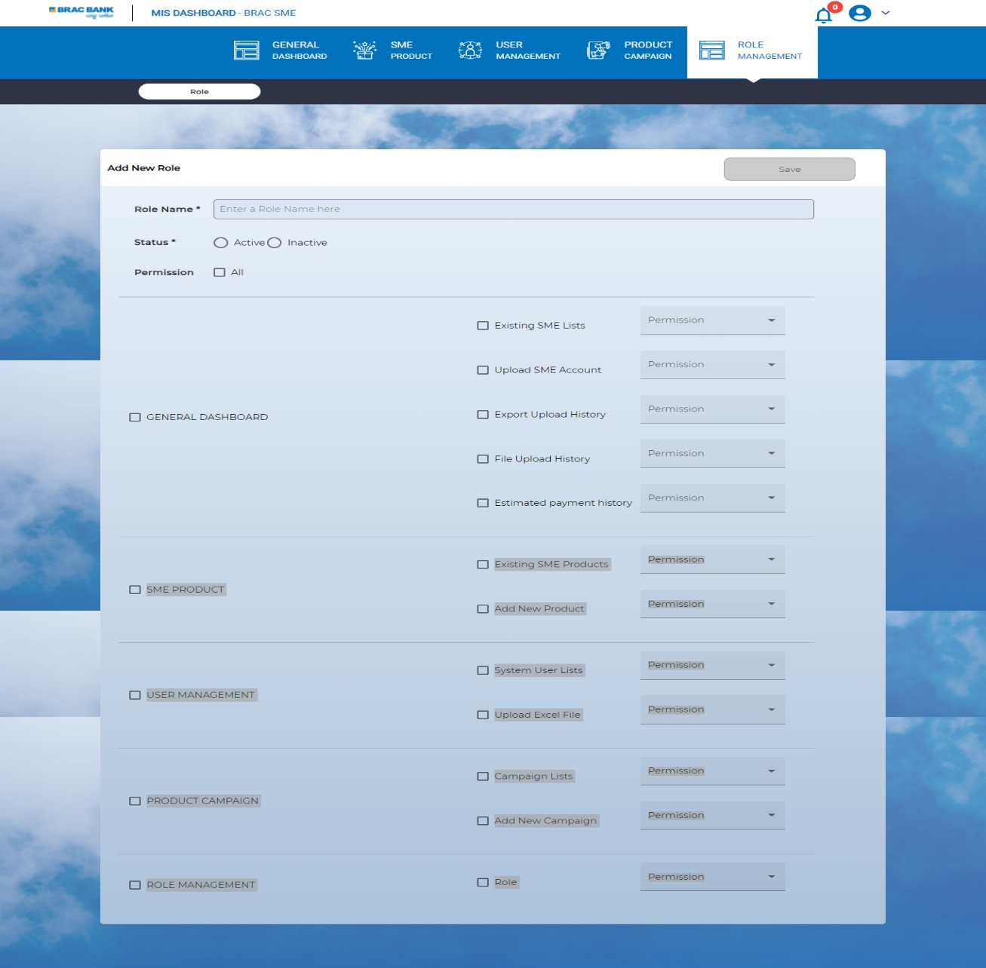

Figure 24 Add New Role Form

* Clicking on Add New Role button user will redirect Add New Role form;
* Enter name of the role In the **Role Name** field
* Set status **Active** or **Inactive**
* Here user find relevant field and checkboxes for relevant permission for that role, dropdown menu;
* Clicking on the **Save** button will create a new role;

## Notification Module

**Click to Access**

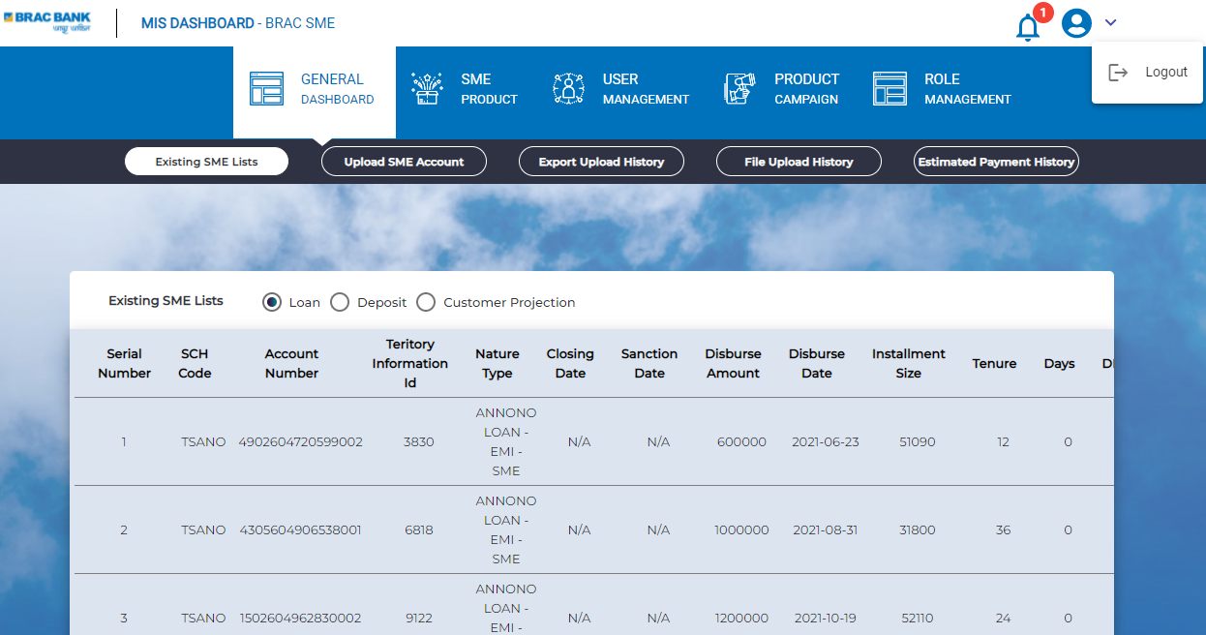

Figure 25 Notification & Logout

**Click to Log out**

* User will get In App Notification in the Bell button.
* Clicking on the **Logout** button user will log out of the system.

### In App Notifications

Figure 26 In App Notifications

* Clicking on the Bell button user will be able to see all the user relevant in-App Notifications of the system;

Thank You

For Using

SME Dashboard